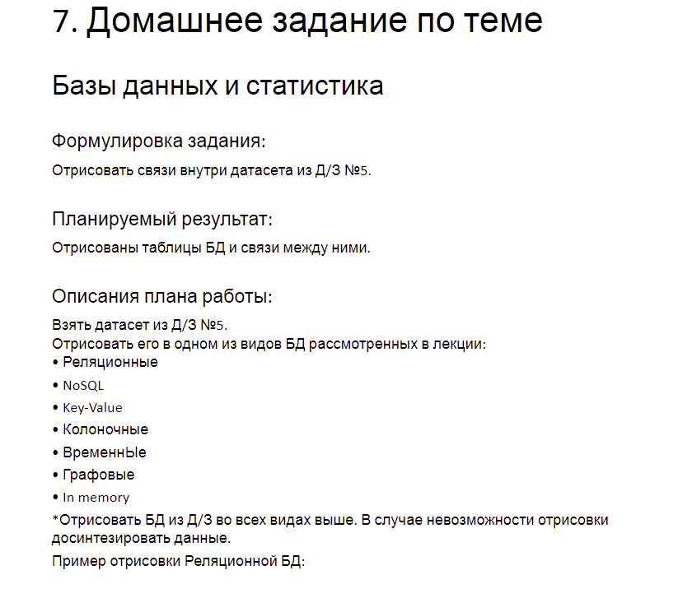

Ссылка на схему: https://viewer.diagrams.net/?tags=%7B%7D&highlight=0000ff&edit=_blank&layers=1&nav=1&title=%D0%A1%D1%85%D0%B5%D0%BC%D0%B0%20%D0%91%D0%94.drawio#R7V3dk5s2EP9b%2BuCZ5sE3fIMfcx9JOtN0bnKZJn3qyEZnq8bIlfHZzl9fCQQGSQTss4V75ulAEgL2t9r97a7wDey7xfYjAcvZZxzCaGAZ4XZg3w8sy3Rsh%2F5hLbusxbf9rGFKUMgH7Rue0A%2FIGw3eukYhXFUGJhhHCVpWGyc4juEkqbQBQvCmOuwZR9W7LsEUSg1PExDJrd9QmMyy1sDy9%2B2fIJrO8jub3ijrWYB8MH%2BT1QyEeFNqsh8G9h3BOMmOFts7GDHh5XLJrvtQ01s8GIFx0uaCT%2F%2F8%2BfANf7Z%2Fn%2F8AYPT49fvHb9GQz%2FICojV%2FYf6wyS6XAMHrOIRsEmNg325mKIFPSzBhvRuKOW2bJYuInpn0EERoGtPjCD7Th7rls0OSwG3tY5uFMKgWQbyACdnRIfwCh4sv1x9%2ButmDYeZDZhUgeCPgCjAtZt7LiB5wMR0gMkshMi9ib7tagrgiO%2B%2FfNUP3doIjTAb2e9pJpuNfbXtg0Xsb%2B7%2FvUllR7YyT4TNYoGiXjV7gGK8yYRf9q3SNsF7TWW7LHdl9WU%2BMyQJEpb4XQBCgfyk8IFkTtqJ%2BOm4ClnVDNlzKrNM3jKwngkkCyZA9K4qn8pWYLGcg5lNaWRvViWTIFSYVTTZv0YWo2sX8Rkb%2BpmlPQuhcz3T6%2FEYxFxDVinTFl%2B6ywSSsPlcxF32V8RzR6dicq4TgORxyvaqMG4PJfJoug6GApOW6GYTlg3elJw3hBBOQIBwPkxmazGO44o%2BHYpSgXDzi2BKUPx1XepzKuOcIg0QUTohWywjs8uERoh2W8QtaLDFJQJyJPldZejRlfx8nEaCPzDWcLphMybNOyVaw52s2Eqe3Co5sFQKFUbDPZRNsySag8G8uOiZuDyyYDOLxaplhoWhC9M1r5FlvYJkQEfVW73nzAoUhu%2FiWLnH0A4zTidgaXWI6f%2Fra7u3AvWczrROc2ZJ04kz%2F7zKFuuda84yiSGjSY9INneh5EnoxWMBD8UuxukoAC7TKCNo6EfSbaQyMw%2FeMD%2B4FUQKlynHgFiXfS8d%2FseMby%2BWn99tS3%2F0uP4npi3zn86Un5cvY%2Bf669Cy%2FUEmZYCjRUgEc%2BnJ4TSawmdwlgExh0jROBruEpqsAM28jMKLO6KX6uCqE%2BR0ecWrpcl2yR4IpF4lb9pr8qjK%2FFSZyBK20PWGiTA7SRKnCFa99vA4GF0%2BlqWwbDW8evujh0qNaLj3OOcYdGKO4xD%2FG3ZMPUY622y37yOGp0o9McOdhHxMqKUj%2Br%2B5LxM%2BT8dNLQEw5DE8ZyGEQXhEBEREcKRDUSkBMVVagZyBBSwYSdMlA3FFVmRzDPY6BeJJfECY6MwMxHZUfOCYMNfaJgGdMIFMPy5jDXTk%2FcJWGxrQUlsbXamnkaFXCouuUbVBl4qr0jKVysOb5pKaKEAWm%2BRVN5tRKXRTVlERpyqLUyzXlMIfaGC66PtV1zFLQzDXlmCteL8aUzVvGgTBeEeGUcFTFzloZpyUHfRIWV8g4c%2FfYnPTy1IDr4ZyBXdUnNxD0pC3nDATFdEWFOzPntOTQlfqDxoroGJMQknL96gWQX4fDcntWRxMLUmI%2BqFKP6knuKYybrSAZeklubstKWvWBvk7vog5xUSMFipZOFB23hYuiRv%2BJn9IXRcnuS2pZcfyw77llGw%2F43iDTqkJX8nEPX6gwv%2BLPIN7V%2Bjfzxkhn2Ps402lwcvTkERJEZcJSnvfGiR1WW3%2FlNPorJZEsGl9bp%2FEFI%2BEc6bEcv4YSa%2FJYjhxAU4%2F1sBgDMmfq0ruQU7gQW2F8RlqNT4uacNd5khaxoWpvm1jYPJ3MVDVMIUtSLJTLypNcWJrEkaPso43MdRiQFmtBK3nJAz2xJncwhtdEQVskSVRB9flAbLG%2F%2Ba0lSbpKadSBfyg%2FNOtSbZr4oSvHnrLO6I5ajlK4oUGDnarSOX7QoHXp2RnjnZyXNQY8TnOCrg94Wim0vDu5e4WmmulWlNq0D47CK4pueFVNd%2FcNHWl6280PLcx2r%2BitFL1FvqnrkE9wbk7bOPl8ezBdOVB%2BBKsVjKeQ%2FBbmX4tcDYVtA5CplcPKQfnTmrzQ9d4%2BBhljHF0rgF7nAKp2Ob%2FxIKSFe8ytdaN%2FzAZeSqXWPzauESu1vqXXO%2BbroJqSYjmNPud9GkujKrhpLZt6cuh65OasHuQakN3Oa%2BNei3Cua5ZblZmn%2Bj5Qa2HDk3dGS4WNFX3dS65puIpsqtaahieHV9S6MLH15YwjVoDWaqhX843zIehdbyHD6zwI9K7wC%2BcLKWR4IqjHFjKkic5N%2BC%2F%2Fi2Txk20Vg%2FYUSBdVxNMvNGXh%2FvAo6RrNpBI%2BrR835BRJcHO9i2v%2BBR2rY4biX1Kp3rgZBb7g5czC7bVzc68sLzWmxbxOP5qtU5%2FXOklpojM7SV9OmfQ%2F59b%2FnNtb%2FTm3P5g3vPAfc7MVFRsVCTyfK5IzbOmvhLYkERla18kiuv4hPl9O9D2h8dOyJ%2B%2BN0ClWnV7o5PTiIyCTWQ9dI3RB19ApP6k5ODPcF51qMv%2BqmpNej9gilXTRe2IHreOuxn0Lef2tMUDzO97AWoRSr43RXGEiW3OMFrRJDejSviIJfmMYTjVFEPh2Q4rg3DmBFltlzqpynrh3X8zTtlU537Rucq%2ByK7TwxmqldxRHsCsN46a9%2FqmFnyDNo43anTz26CbfVC1877jX%2FOwhTrsOVFXsrq0wXQbCRm4z%2BHmSrWknt2VXl5Vrn3lZNZv8tlu5s720HZp8TzD5x25Wc4WJbM0f4QSqrdx9Wq5Py73NtFyx4f7ycnNifl61l0tl0sRvP1rEIvR0%2F%2B9wMkuy%2F6dC9sN%2F